2014-TW-01a-EN Moving in hexagonal grids
0 ---- | I: ---- | II: medium | III: easy | IV: easy

Answer Type: Multiple Choice Mandatory for: Group IV

Body

Beavers love the shape of hexagons, so they decided to divide their country into several hexagonal cities. They set a coordinate for each city (see the figure), and set the distance between two neighboring cities is 1. One little beaver is currently in the city (2,1) and its home is in the city (6,9). | 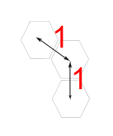
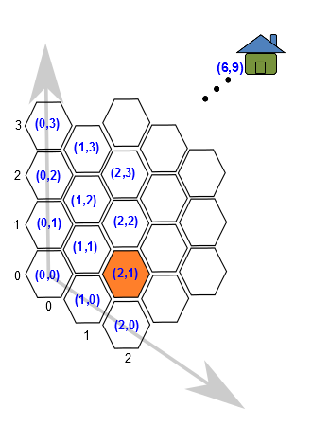

Question

What is the shortest distance between the little beaver's current position and home?

Answer

A) 6
B) 7
C) 8
D) 9

Explanation

The correct answer is C) 8.
To go from the 2nd to the 6th column you need 4 steps and the shortest way is to go diagonal. After these 4 steps you will end up in position (6,5). From (6,5) to (6,9) you also need 4 steps.
In fact, you need 8 steps (4 steps forward and 4 steps diagonal) no matter which order.
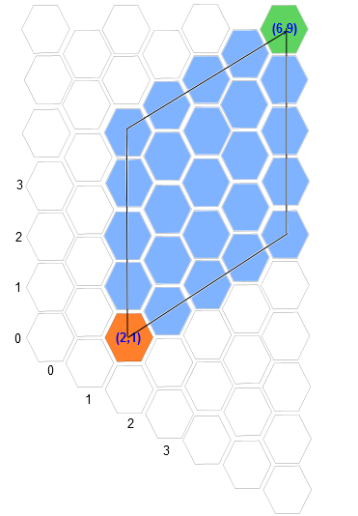

It's informatics

Hex coordinates are commonly used in computer games or computer graphics. Calculating distances between grids in hex coordinate is the basis of using hex coordinates. In addition, since students are already familiar with Cartesian coordinates, it is a good practice for students to compare the differences between Cartesian coordinates and hex coordinates.

Keywords

Hex coordinate

Websites

http://en.wikipedia.org/wiki/Coordinate_system
http://keekerdc.com/2011/03/hexagon-grids-coordinate-systems-and-distance-calculations/

Internal Use

Wording

List of word used to name important things in the task body (concepts, definitions, objects, names, etc.) This is to ensure the consequent use of terms in the task body and facilitates translation.

Comments

Author, e-mail, Date (YYYY-MM-DD), Comment.
Hein,2014-05-23,The explanation states that 8 is the shortest distance. But it does not argue, why there can not be a shorter path.
Te-Chin Chu,dieter@csie.ntnu.edu.tw,2014-05-28, The explanation has been revised.
2014-06-04 Jonas Ruigys, Haim Averbuch, Elena Sutkutė: We changed the picture and added another one to explain better the distance between hexagon cities.

Graphics

The image is made by the author.

Files

All additional files for this task (graphics, scripts, etc.)
2014-TW-01a-EN.odt (this file)
2014-TW-01a.svg

Authorship

Te-Chin Chu, dieter@csie.ntnu.edu.tw, Taiwan.

License

Copyright © 2014 Bebras – International Contest on Informatics and Computer Fluency. This work is licensed under a Creative Commons Attribution-NonCommercial-ShareAlike 3.0 Unported License (CC BY-NC-SA 3.0). Visit: http://creativecommons.org/licenses/by-sa-sa/3.0/

